SIMATS ENGINEERING
Saveetha Institute of Medical And Technical Sciences
ECA5603 5G/6G COMMUNICATION SYSTEM
Assignment 1 (CO1): Cellular Network Evolution, Cellular Planning and Spectrum Allocation
Engineering Design Report: Integrated 5G/6G-Ready Smart-City Network for Tamil Nadu, Karnataka, Kerala, Maharashtra, Gujarat and Uttar Pradesh
Item | Details
Student name | MONISHA K
Register number | 192412055
Course | ECA5603 5G/6G Communication System
Assessment | Open-ended engineering design report, 100 marks (K4 Analyze, K5 Evaluate, K6 Create)
Report structure | Requirements → analysis → calculations → comparison → recommendation

Executive Summary and Basis of the Study
This report designs a 5G/6G-ready network for six Indian states. It follows the six stages of the assignment: requirements, spectrum and planning, quantitative models, architecture comparison, integrated design, and validation. Numerical work was done in Python (Erlang B recursion, link budgets, site counts, a 24-hour slice-allocation simulation); the methods and engineering meaning are given beside every result.
Headline result. A heterogeneous architecture (Architecture B: macro cells on 700 MHz and 3.3–3.67 GHz, small cells on mid-band and 26 GHz, edge computing and AI-assisted slicing) scores 4.35 / 5 against 2.70 / 5 for a macro-only design (Architecture A) in the weighted decision matrix. The planning model gives about 115,253 macro sites plus 12,310 small cells for the six states. In simulation the AI-assisted allocator cut unserved traffic from 4.1% to 0.0% in a peak-hour surge, and kept the public-safety slice fully served during a site-failure plus emergency event (baseline lost 22.3% of it). Recommendation: deploy with modifications (Section 8).

Important assumptions (please read)
- Erlang B inputs. The assignment text refers to a "supplied subscriber count, busy-hour traffic per subscriber and available traffic channels", but no numerical values were included in the question paper. I therefore adopted a reference cell of 2,000 subscribers, 0.025 Erlang (90 s) per subscriber in the busy hour and 55 available channels, with the 2% target blocking. All Erlang results are shown with a sensitivity table so they can be re-run quickly with the official values.
- State data (population, area, urban share) are rounded approximate figures; 5G active-subscriber share (30%), busy-hour demand per subscriber and cost values are planning assumptions, not measured data. They are listed where used and should be replaced by operator measurements before deployment.
- Idealised channel counts in Section 1 ignore guard bands, duplexing overhead (FDD duplex gap or TDD guard period and UL/DL split), control and broadcast channels, and reuse. This is stated explicitly where each calculation is made, as the assignment requires.
- Simulation results are from a simplified analytical/time-step model and illustrate relative behaviour; they are not a substitute for a full ns-3 or vendor-tool system simulation.

1. Evolution of Mobile Communication Systems (1G–6G)
Each generation changed the access method, channel bandwidth and the unit of resource that the network allocates. The progression from fixed narrowband channels to flexible OFDMA resource blocks is what allows 5G to serve eMBB, URLLC and mMTC from one network.
Table 1. Comparison of 1G–6G technologies
Gen | Representative standard | Multiple access | Channel / carrier bandwidth | Typical peak rate | Key capability
1G (1980s) | AMPS, TACS, NMT | FDMA (analog FM) | 30 kHz | ~2.4 kbps (data) | Analog voice, handoff, cellular reuse
2G (1991–) | GSM; IS-95 (CDMA) | TDMA/FDMA; CDMA | 200 kHz (8 slots); 1.25 MHz | 9.6–14.4 kbps; GPRS ~171 kbps; EDGE ~384 kbps | Digital voice, SMS, encryption, roaming
3G (2001–) | UMTS/WCDMA, HSPA | CDMA | 5 MHz | 384 kbps–2 Mbps; HSPA+ 42 Mbps | Mobile internet, soft handover, packet core
4G (2009–) | LTE, LTE-Advanced | OFDMA (DL), SC-FDMA (UL), MIMO | 1.4–20 MHz (carrier aggregation to 100 MHz) | ~150 Mbps (LTE); ~1 Gbps (LTE-A) | All-IP, VoLTE, HD video, ~10 ms RAN latency
5G (2019–) | 3GPP NR (Rel-15/16/17) | CP-OFDM OFDMA, flexible numerology | Up to 100 MHz (FR1), 400 MHz (FR2) | IMT-2020 target 20 Gbps DL | eMBB, URLLC (~1 ms), mMTC, slicing, SBA core
6G (~2030, targets) | IMT-2030 vision (not yet standardised) | OFDMA-evolved, AI-native air interface | GHz-scale, sub-THz candidates | Targets up to ~1 Tbps | ISAC, AI-native networking, 0.1–1 ms latency, cm-level sensing
6G figures are research and ITU-R IMT-2030 framework targets, not committed specifications.

1.1 Idealised channel allocation and spectrum utilisation
For an idealised count, the number of channels in one direction is N = floor(B / B_c) (multiplied by time slots for TDMA). For OFDMA systems the resource unit is the physical resource block (PRB, 12 subcarriers).
N_ideal = B_total / B_channel (x slots per carrier for TDMA)
Table 2. Idealised versus standard channel counts (one direction)
System | Spectrum / carrier | Idealised count | Standard / deployed value | Idealised spectrum use | Overheads hidden by the ideal
1G AMPS | 25 MHz / 30 kHz | 833 | 832 channels | 100% | Guard bands, control channels
2G GSM | 25 MHz / 200 kHz × 8 slots | 125 × 8 = 1000 | 124 × 8 = 992 (traffic + control) | 100% | 100 kHz edge guard, BCCH/SDCCH, TDMA framing
3G WCDMA | 25 MHz / 5 MHz | 5 carriers | ~4 usable (guard) | 100% | Soft capacity limited by interference; code and power limits
4G LTE 20 MHz | 20 MHz / 180 kHz | 111.1 PRB | 100 PRB (18 MHz occupied) | 100% (ideal) vs 90% (real) | Spectral-mask guard bands, PDCCH, reference signals
5G NR FR1 | 100 MHz / 360 kHz (30 kHz SCS) | 277.8 PRB | 273 PRB (98.28 MHz) | 100% vs 98.3% | TDD guard period, DL/UL split, SSB, PDCCH, DMRS
5G NR FR2 | 400 MHz / 1.44 MHz (120 kHz SCS) | 277.8 PRB | 264 PRB (380.2 MHz) | 100% vs 95% | Beam-management overhead, blockage-related retransmissions
6G (concept) | 1–10 GHz contiguous (sub-THz) | Not standardised | n/a | n/a | Expected: ultra-wide numerology, sensing resources
Explicit statement on overheads. In Table 2 and in the Erlang B channel counts below, the idealised calculation ignores guard bands, the duplexing method (FDD frequency separation or TDD guard period and UL/DL ratio), control and signalling channels, and cluster-based frequency reuse, unless a reuse factor is stated. Real usable capacity is therefore lower. In the later capacity calculations (Section 4) these effects are brought back in through an overhead factor of 0.8 and a TDD downlink share of 0.74.

Erlang B capacity of 1G and 2G cells (reuse factor 7)
With a 7-cell reuse cluster, the traffic channels available to one cell are 832/7 = 118 (1G) and 992/7 = 141 (2G). Solving Erlang B for 2% blocking gives an offered-traffic capacity of 105.5 E per 1G cell and 128.0 E per 2G cell. At 0.025 E per subscriber this supports about 4,219 and 5,119 subscribers per cell. 2G therefore gained capacity by digitisation (8 slots per 200 kHz carrier) even before the move to data services. These counts also ignore guard bands, control channels and duplexing, as stated above.
Interpretation. From 1G to 5G the allocatable unit shrinks from a 30 kHz whole-call channel to a 180 kHz–1.44 MHz PRB that is shared dynamically among users and slices, and spectral efficiency rises from well under 1 bit/s/Hz to several bit/s/Hz through MIMO and higher-order modulation. 6G is expected to add sensing and AI-native control rather than simply more bandwidth.

2. Stage 1: Problem Analysis and Requirements

2.1 State-wise requirements matrix
Planning inputs per state are in Table 3 (approximate population and area; 5G active share 30% of population at the design horizon; urban fraction of population as shown). Engineering challenges and measurable targets follow in Table 4.
Table 3. State planning inputs and busy-hour demand
State | Pop. (M) | Area (km²) | Urban pop. share | 5G subs (M) | Busy-hour demand (Tbps) | Urban area share
Tamil Nadu | 78 | 130,060 | 48% | 23.4 | 7.31 | 4.0%
Karnataka | 68 | 191,791 | 39% | 20.4 | 5.71 | 2.0%
Kerala | 36 | 38,852 | 48% | 10.8 | 3.38 | 8.0%
Maharashtra | 126 | 307,713 | 45% | 37.8 | 11.41 | 2.5%
Gujarat | 72 | 196,024 | 43% | 21.6 | 6.36 | 2.5%
Uttar Pradesh | 235 | 240,928 | 22% | 70.5 | 15.43 | 1.2%
Busy-hour average rates per active subscriber: urban 0.5 Mbps, suburban 0.25 Mbps, rural 0.08 Mbps (assumed; includes concurrency and traffic mix). Suburban population taken as 35% of the non-urban population.
Table 4. Six-state requirements matrix
State | Distinct characteristics (assumed context) | Major communication challenges | Measurable engineering targets
Tamil Nadu | Chennai metro, automotive and electronics corridors, long coastline | Dense urban hotspots; industrial automation latency; cyclone-time emergency communication | Urban cell-edge DL ≥ 50 Mbps; industrial URLLC ≤ 5 ms; public-safety slice availability ≥ 99.999% in disasters
Karnataka | Bengaluru tech hub, hilly Western Ghats, AV and IT testbeds | Very high urban density; hilly terrain shadowing; V2X trials | Urban DL ≥ 100 Mbps in IT zones; V2X E2E ≤ 10 ms; hill-region coverage ≥ 95% area
Kerala | Continuous linear settlement, high rural density, heavy monsoon, flood risk | Dense suburban-rural mix (no clear rural gap); rain fade on mmWave; flood-resilient backhaul | Pop. coverage ≥ 99.5%; backhaul availability ≥ 99.99%; telemedicine RTT ≤ 20 ms
Maharashtra | Mumbai–Pune megacity belt, ports, industrial estates, expressways | Highest urban traffic concentration; port and factory automation; corridor handover | Urban busy-hour PRB utilisation ≤ 70%; corridor handover interruption ≤ 0 ms (make-before-break); IIoT ≤ 5 ms
Gujarat | Industrial and petrochemical clusters, ports, arid regions, coastal cyclone exposure | Industrial URLLC; long sparse links in arid areas; cyclone resilience | Industrial reliability ≥ 99.999%; rural coverage with ≤ 8 km radius; restoration ≤ 4 h after outage
Uttar Pradesh | Largest population, high rural share, expressways, flood plains | Massive rural capacity and uplink demand; mMTC density; limited fibre in rural areas | Rural cell-edge DL ≥ 10 Mbps; mMTC density ≥ 10⁶/km² in industrial clusters; blocking ≤ 2%

2.2 Application classification
Table 5. Applications by 5G service category
Application | Category | Dominant requirement | Indicative target
High-definition / 4K video, AR | eMBB | Throughput, capacity | 25–100 Mbps per user; PRB utilisation ≤ 70%
Autonomous / connected transport | URLLC (+ eMBB for map/sensor uploads) | Latency, reliability, mobility | ≤ 10 ms E2E, 99.999%, handover interruption ~0 ms
Remote healthcare / tele-surgery | URLLC | Latency, reliability, security | ≤ 10–20 ms RTT, 99.999%, encrypted
Industrial automation (PLC, robots) | URLLC | Deterministic latency | 1–5 ms, jitter < 1 ms
Massive IoT (meters, sensors) | mMTC | Connection density, energy | 10⁶ devices/km², 10-year battery, ~2 kbps average
Emergency / public safety | URLLC + MCPTT (mission-critical) | Coverage, priority, availability | Pre-emptive priority, 99.999% availability, works on 700 MHz

2.3 Constraints and interactions
- Coverage vs frequency: higher bands give bandwidth but short range (Section 4.4); coverage needs low bands.
- Throughput vs cost and energy: densification raises capacity roughly in proportion to site count but also raises CAPEX, backhaul, energy and interference-management complexity.
- Latency vs centralisation: a centralised core saves cost and simplifies management but adds ~5 µs per km of fibre; edge computing reduces latency but raises the number of sites to operate and secure.
- Reliability vs cost: redundancy (dual connectivity, diverse backhaul, N+1 core pools) raises availability at higher cost.
- Interference vs reuse: reuse-1 maximises capacity but needs beamforming, ICIC and scheduling coordination to control co-channel interference.
- Security vs latency: stronger encryption and inspection add processing time; hardware acceleration at edge nodes is needed for URLLC slices.

2.4 Constrained optimisation formulation
Design variables: site counts by type (N_macro, N_small), spectrum assignment per layer (b_i in MHz), cell radius R_i, sectorisation, MIMO configuration, edge-node count N_edge, slice resource shares α_s.
minimise Cost = Σ (CAPEX_i + 5·OPEX_i)·N_i and Energy = Σ P_i(load)·N_i
Subject to: (i) coverage: P(SINR ≥ SINR_min) ≥ 99.5% of population; (ii) capacity: Σ N_i C_i ≥ D / ρ_max with ρ_max = 0.7; (iii) blocking: Erlang B(A, N) ≤ 2%; (iv) latency: L_radio + L_backhaul + L_core + L_edge ≤ L_max (10 ms vehicles, 5 ms industry); (v) reliability ≥ 99.999% for critical slices; (vi) Σ α_s = 1 with minimum guarantees for URLLC and public safety; (vii) spectrum: Σ b_i ≤ licensed bandwidth; (viii) EMF and regulatory limits.

2.5 Performance indicators
KPI | Target | KPI | Target
Population coverage | ≥ 99.5% | Cell-edge DL rate (urban / rural) | ≥ 50 / ≥ 10 Mbps
Busy-hour PRB utilisation | ≤ 70% (alarm 85%) | Call/session blocking | ≤ 2%
URLLC E2E latency (99th pct) | ≤ 10 ms (vehicles); ≤ 5 ms (industry) | URLLC reliability | ≥ 99.999%
Handover interruption | ≤ 0 ms (DAPS) corridors | mMTC density | 10⁶ devices/km²
Energy saving from AI | ≥ 10% vs always-on | Public-safety availability | ≥ 99.999%
Design Decision 1 (priorities). The most critical requirements are (1) coverage and availability for emergency and critical services (a failure here is a safety issue), (2) latency and reliability for URLLC (a missed deadline is a functional failure for vehicles and surgery), (3) busy-hour capacity, and (4) cost. Conflicts are resolved by tiering: public-safety and URLLC slices get guaranteed resources and pre-emption, eMBB uses the remaining capacity and degrades gracefully, and cost is controlled by using low-band macro cells only where coverage needs them and adding mid-band and mmWave capacity only where demand justifies it.

3. Stage 2: Spectrum, Radio Access and Cellular Planning

3.1 Spectrum comparison
Free-space path loss at 1 km is FSPL = 20log₁₀(d_km) + 20log₁₀(f_MHz) + 32.44 dB, giving 89.3 dB at 700 MHz, 103.3 dB at 3.5 GHz and 120.7 dB at 26 GHz. A log-distance model PL(d) = FSPL(1 km) + 10n log₁₀(d) with n = 3.2, 3.5 and 2.8 (assumed typical values) was used for Figure 1.
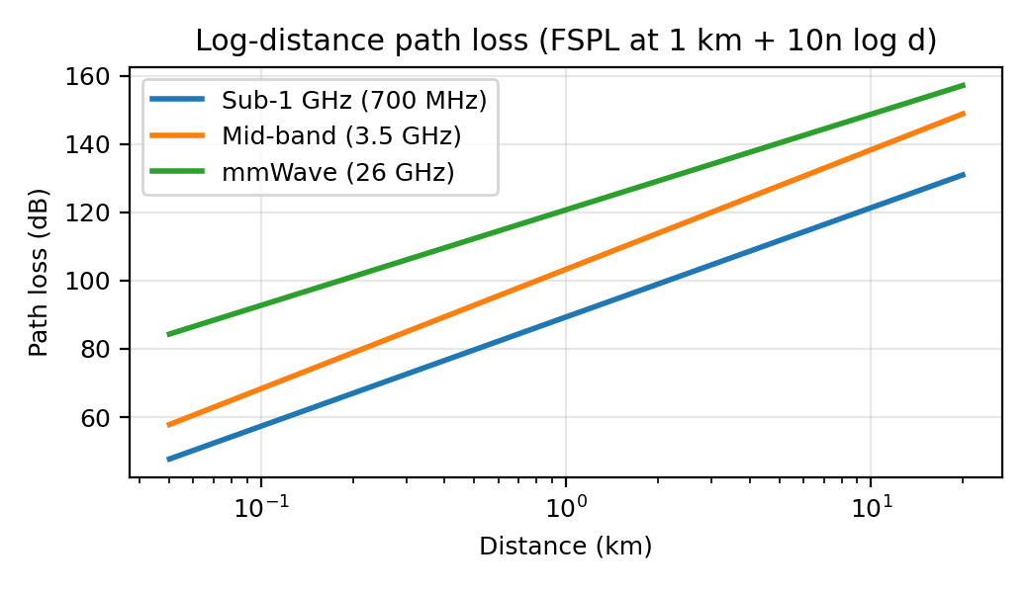
Figure 1. Path loss versus distance for the three spectrum ranges
Table 6. Spectrum range comparison (India-relevant example bands)
Range | Example bands | Bandwidth per carrier | Path loss at 1 km | Practical cell radius* | Relative deployment cost | Best use
Sub-1 GHz | n28 (700 MHz), 800/900 MHz | 5–20 MHz | ~89 dB (FSPL) | ~7.9 km (rural UL) | Lowest per km² covered | Rural, emergency, mMTC, indoor penetration
Mid-band 1–6 GHz | n78 (3.3–3.67 GHz), 1800/2100/2300 MHz | 20–100 MHz | ~103 dB | ~1.66 km (urban UL) | Medium | Urban, suburban, industrial, corridors
mmWave >24 GHz | n258 (26 GHz, 24.25–27.5 GHz) | 100–400 MHz | ~121 dB | ~0.32 km (hotspot UL) | Highest per km² (many cells) | Hotspots, venues, fixed wireless, backhaul
*From the uplink budgets in Table 7; sub-1 GHz and mid-band radii are coverage limits before capacity-driven shrinking.
Table 7. Uplink link budgets for an edge user (assumptions as shown)
Case | UE power (dBm) | gNB gain (dBi) | Bandwidth (MHz) | Noise figure (dB) | SNR required (dB) | Sensitivity (dBm) | Margins (dB) | Max path loss (dB) | Radius (km)
Sub-1 GHz rural UL | 23 | 15 | 5 | 3 | 3 | -101.0 | 21 | 118.0 | 7.87
Mid-band urban UL | 23 | 24 | 20 | 3 | 3 | -95.0 | 31 | 111.0 | 1.66
mmWave hotspot UL | 23 | 28 | 100 | 7 | 3 | -84.0 | 28 | 107.0 | 0.32
Sensitivity = −174 + 10log₁₀(B_Hz) + NF + SNR_req; maximum path loss = P_UE + G_gNB − Sensitivity − Margins (shadowing, body, penetration/foliage/rain); radius from the log-distance model. Rural 700 MHz therefore supports ~6–8 km (6 km adopted with a safety factor); urban 3.5 GHz supports ~1.7 km on coverage but capacity forces smaller cells; 26 GHz is limited to ~0.3 km.

3.2 Cell-type comparison
Table 8. Macro, micro, pico and other small cells
Cell type | Typical radius | Tx power | Typical spectrum | Capacity (assumed) | Role
Macro | 0.5–6 km | 40–80 W | 700 MHz, 1800, 3.5 GHz | ~1.4 Gbps urban site (3 sectors, 100 MHz + 40 MHz); ~0.25 Gbps rural | Wide-area coverage, corridors
Micro | 100–500 m | 5–20 W | 3.5 GHz | ~0.8 Gbps | Street-level infill, suburban capacity
Pico | 20–100 m | 0.25–2 W | 3.5 GHz, 26 GHz | ~1 Gbps (26 GHz, 400 MHz) | Malls, stations, stadiums, offices
Femto / indoor DAS | 10–50 m | < 0.25 W | 3.5 GHz | ~0.3–1 Gbps | Hospitals, factories, buildings
IAB / relay | 100–300 m | Low | 26 GHz backhaul + 3.5 GHz access | Shares donor capacity | Rural or temporary fibre-less sites

3.3 Impact of OFDMA, massive MIMO, beamforming and frequency reuse
- OFDMA: allocates PRBs per user and per slice in time and frequency; scalable numerology (15, 30, 60, 120 kHz) trades symbol length (latency) against Doppler tolerance. Gain: fine-grained scheduling and frequency-selective gain.
- Massive MIMO (e.g. 32T32R–64T64R at 3.5 GHz): spatial multiplexing and multi-user MIMO raise cell-average spectral efficiency to ~6 bit/s/Hz (planning value) and array gain improves coverage by roughly 10–24 dB of beamforming gain.
- Beamforming: narrow beams cut interference to other cells and are essential at 26 GHz to overcome ~17 dB extra path loss relative to 3.5 GHz; cost is beam-tracking overhead and blockage sensitivity.
- Frequency reuse: NR deployments use reuse-1 per carrier with interference coordination, giving the highest spectral reuse; classical reuse clusters (N = 3, 4, 7) are examined below for interference.

3.4 Co-channel and adjacent-channel interference
For a hexagonal layout, D/R = √(3N) and SIR = (D/R)^n / i₀, with n = 3.5 and i₀ = 6 first-tier co-channel interferers (omnidirectional) or 2 (120° sectors).
SIR = (D/R)^n / i0 , D/R = sqrt(3N)
Table 9. SIR for different reuse clusters (n = 3.5)
Cluster size N | D/R | SIR omni (dB) | SIR 120° sectors (dB) | Channel share per cell
3 | 3.00 | 8.9 | 13.7 | 1/3
4 | 3.46 | 11.1 | 15.9 | 1/4
7 | 4.58 | 15.4 | 20.1 | 1/7
A cluster of N = 3 with sectoring gives ~13.7 dB, adequate for modern adaptive modulation, whereas N = 7 omnidirectional gives 15.4 dB but wastes spectrum (each cell uses only 1/7 of the band). This is why NR uses reuse-1 with beamforming and ICIC rather than large clusters.
Mitigation: (1) beamforming and nulling, (2) inter-cell interference coordination and coordinated scheduling (CoMP), (3) fractional frequency reuse at cell edges, (4) power control and downtilt optimisation, (5) AI-based dynamic spectrum and RRM, (6) uplink/downlink TDD frame alignment across neighbouring cells and guard periods to prevent cross-link interference, (7) adjacent-channel control through spectral masks (ACLR), filtering and guard bands of 1–5 MHz between operators/blocks, and (8) site-by-site interference measurement before activation.

3.5 Cell splitting and sectoring
Using the Erlang B reference cell (A = 50 E, 61 channels at 2%): 3-sector split gives A = 16.7 E per sector needing 25 channels each, 75 in total; cell splitting (radius halved, area/4) gives A = 12.5 E per new cell needing 20 channels, 80 in total across 4 cells. The channel utilisation falls from 81% (single cell) to 66% (sectored) and 62% (split) because of reduced trunking efficiency. Splitting gives the largest traffic capacity (4× area reuse), sectoring is cheaper (no new sites, but needs antenna and handover changes) and also improves SIR (Table 9). Recommendation: sectoring first, splitting or small cells where utilisation still exceeds 70%.

3.6 Number of cells for stated demand
Method: sites = max(coverage sites, capacity sites) for each layer. Coverage sites = area / (2.598R²) with R = 0.5 km (urban, mid-band macro), 1.2 km (suburban) and 6 km (rural, 700 MHz). Capacity sites = demand / (ρ_max · site capacity) with ρ_max = 0.7 and site capacities from Table 8 (rural 0.25 Gbps: 10 MHz at 700 MHz plus ~20 MHz of 1800/2100 MHz). In Architecture B, 25% of urban demand is offloaded to 26 GHz small cells of 0.96 Gbps (400 MHz × 4 bit/s/Hz × 0.75 × 0.8).
Table 10. Cell-count estimate per state (sites; coverage-limited / capacity-limited)
State | Urban cov / cap | Suburban cov / cap | Rural cov / cap | Macro sites (B) | Small cells (B) | Macro sites (A)
Tamil Nadu | 8,010 / 5,731 | 5,562 / 1,901 | 1,112 / 3,616 | 17,188 | 2,089 | 17,188
Karnataka | 5,906 / 4,059 | 5,127 / 1,944 | 1,805 / 3,698 | 14,730 | 1,480 | 14,730
Kerala | 4,785 / 2,645 | 3,323 / 878 | 249 / 1,669 | 9,777 | 964 | 9,777
Maharashtra | 11,844 / 8,679 | 8,225 / 3,248 | 2,879 / 6,178 | 26,247 | 3,164 | 26,247
Gujarat | 7,545 / 4,739 | 5,240 / 1,924 | 1,834 / 3,658 | 16,443 | 1,728 | 16,443
Uttar Pradesh | 4,451 / 7,913 | 6,440 / 8,592 | 2,287 / 16,340 | 30,867 | 2,885 | 32,845
Total |  |  |  | 115,253 | 12,310 | 117,231
Planning-level, greenfield-equivalent counts for one shared grid. Existing sites would be reused through infrastructure sharing, so new-build numbers are lower.
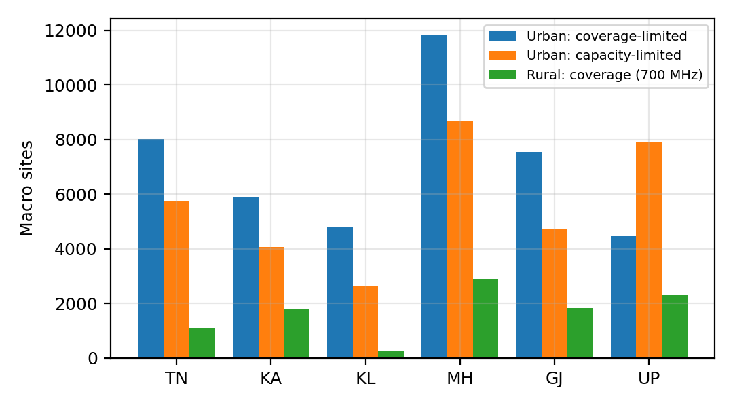
Figure 2. Coverage-limited versus capacity-limited macro sites by state
Interpretation. In urban areas of TN, KA, KL, MH and GJ the number of sites is set by coverage (cell radius), so capacity is available with headroom (cap/cov < 1). In Uttar Pradesh the urban capacity requirement exceeds coverage sites (ratio 1.78), and in all states the rural layer is capacity-limited by narrow low-band spectrum (cap/cov from 2.0 to 7.1), which motivates adding 1800/2100 MHz capacity layers and better spectral efficiency in rural sectors.

3.7 State-wise spectrum and radio-access planning matrix
State | Urban | Suburban / industrial | Rural | Transport corridors | Special measures
Tamil Nadu | n78 macro 64T64R + n258 hotspots (Chennai, Coimbatore) | n78 micro, 1800 MHz | n28 700 MHz macro, R~6 km | Chennai–Bengaluru industrial corridor: n78 + edge | Coastal-resilient sites, satellite/IAB backup
Karnataka | n78 + n258 in Bengaluru tech parks | n78 micro/pico | n28 with elevated sites in hills | AV test corridors: n78 + edge | Terrain-aware planning, hill-top repeaters
Kerala | n78 dense macro/micro, limited n258 | n78 micro (continuous settlement) | n28 + 1800 MHz, smaller R due to density | Coastal highway: n78 | Flood-proof backhaul, monsoon rain-fade margin for mmWave
Maharashtra | n78 + n258 in MMR/Pune, stations, venues | Industrial estates: private/slice n78 | n28 macro, R~6 km | Mumbai–Pune and expressways: n78 + n28 + edge | Highest small-cell share, port IIoT edge
Gujarat | n78 macro, n258 selective (GIFT city, venues) | Industrial/petrochemical: private slices, n78 indoor | n28, long links in arid zones | Ahmedabad–Mumbai corridor, ports | Explosion-proof IIoT, cyclone-hardened sites
Uttar Pradesh | n78 macro + micro; fewer n258 | n78 micro, 1800 MHz capacity | n28 + 1800/2100 capacity layers; IAB for fibre gaps | Expressways: n78 + n28 | Largest rural capacity programme, solar-hybrid power
Design Decision 2 (spectrum and architecture per state). Recommended mix: n28 (700 MHz) everywhere for coverage, emergency and mMTC; n78 (3.3–3.67 GHz, 100 MHz) as the main capacity layer in urban, suburban, industrial and corridor areas; n258 (26 GHz) only in hotspots and fixed-wireless. A uniform band or cell type is not suitable because states differ strongly in urban share (22% in UP versus 48% in TN/KL), area (39,000 km² in Kerala versus 308,000 km² in Maharashtra), terrain, climate (monsoon, cyclone) and industrial profile. A single mmWave design would be uneconomic over ~85% of the area; a low-band-only design cannot carry urban busy-hour demand.

4. Stage 3: Quantitative Capacity, Latency and Reliability Models

4.1 Erlang B model: traffic channels and blocking
Model. Erlang B assumes Poisson call arrivals, general holding times, N identical channels and blocked calls cleared. The blocking probability for offered traffic A (Erlang) on N channels is:
B(A,N) = (A^N / N!) / Σ_{k=0..N} (A^k / k!)
It is evaluated with the stable recursion B(A,0) = 1, B(A,n) = A·B(A,n−1) / (n + A·B(A,n−1)). Offered traffic is A = U × a, where U is the number of subscribers and a the busy-hour traffic per subscriber (Erlang).
Table 11. Input parameters and results (reference cell)
Quantity | Symbol | Value | Comment
Subscribers served | U | 2,000 | Assumed (not supplied)
Busy-hour traffic / subscriber | a | 0.025 E (90 s per hour) | Assumed
Offered traffic | A = U·a | 50.0 E
Available traffic channels | N_avail | 55 | Assumed
Blocking with available channels | B(A, 55) | 5.37% | Exceeds the 2% target
Target blocking | GoS | 2%
Channels required at 2% | N_req | 61 | B(A, 61) = 1.75%
Additional channels needed | N_req − N_avail | 6 | +11% capacity
Channels for 1% / 5% blocking |  | 64 / 56 | Shows steep cost of tighter GoS
Carried traffic / channel utilisation at N_req | A(1−B)/N | 81%
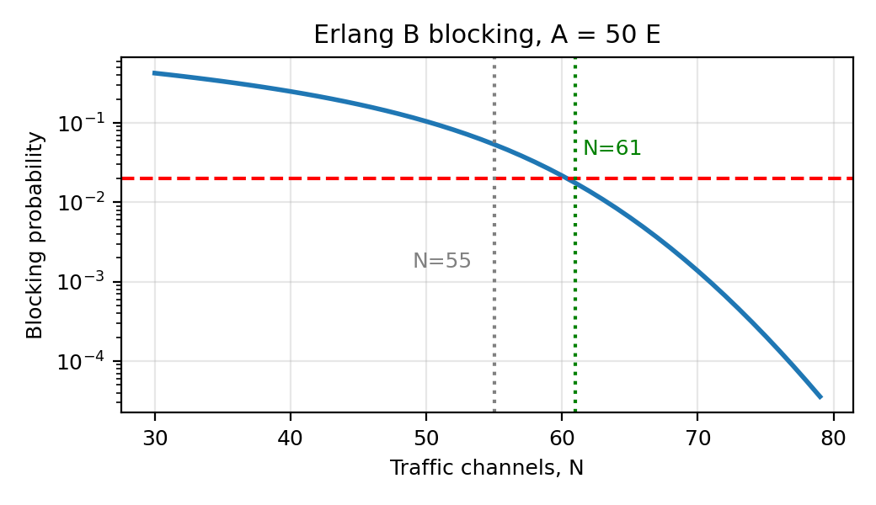
Figure 3. Erlang B blocking probability versus number of channels (A = 50 E)
Interpretation. With 55 channels the cell blocks 5.4% of attempts, more than twice the 2% target. 61 channels are needed (6 more, or 11% more). Blocking falls rapidly near the operating point (Figure 3), so a small shortfall causes a large blocking increase. At 61 channels utilisation is 81%, which shows the efficiency of large channel groups (trunking gain).
Table 12. Sensitivity of channel requirement at 2% blocking
Subscribers | a = 0.020 E (A, N) | a = 0.025 E (A, N) | a = 0.030 E (A, N)
1,000 | 20 E, 28 ch | 25 E, 34 ch | 30 E, 39 ch
2,000 | 40 E, 50 ch | 50 E, 61 ch | 60 E, 71 ch
3,000 | 60 E, 71 ch | 75 E, 87 ch | 90 E, 103 ch
4,000 | 80 E, 92 ch | 100 E, 113 ch | 120 E, 133 ch
Slice pools. Applying the same 2% target to three circuit-like pools:
Traffic class | Users | Erlang / user | Offered A (E) | Channels at 2% | Blocking
VoNR/voice (eMBB users) | 2,000 | 0.025 | 50.0 | 61 | 1.75%
URLLC sessions (vehicle+industrial) | 300 | 0.08 | 24.0 | 33 | 1.58%
Public-safety push-to-talk | 120 | 0.1 | 12.0 | 19 | 1.65%
Splitting and sectoring in Erlang terms: one 61-channel cell (A = 50 E) versus 3 sectors × 25 = 75 channels (− trunking efficiency) versus 4 split cells × 20 = 80 channels, which carry four times the area traffic with more total channels but much lower per-cell load. As noted in Section 1, these channel counts ignore guard bands, control channels and duplexing overhead.

4.2 Aggregate traffic demand by application
Assumptions: HD video is 65% of total eMBB busy-hour demand (Table 3); connected/autonomous vehicles 20 Mbps each (sensor sharing, HD maps; active counts are assumed); industrial IoT devices average 2 kbps; remote healthcare sessions 25 Mbps each.
Table 13. Busy-hour application demand (Gbps)
State | HD video | Autonomous / connected vehicles (active) | Industrial IoT / mMTC (million devices) | Remote healthcare (sessions)
Tamil Nadu | 4,754 | 600 (30,000) | 40.0 (20 M) | 100 (4,000)
Karnataka | 3,714 | 600 (30,000) | 32.0 (16 M) | 100 (4,000)
Kerala | 2,194 | 200 (10,000) | 16.0 (8 M) | 75 (3,000)
Maharashtra | 7,413 | 1,200 (60,000) | 60.0 (30 M) | 150 (6,000)
Gujarat | 4,135 | 600 (30,000) | 36.0 (18 M) | 100 (4,000)
Uttar Pradesh | 10,027 | 1,000 (50,000) | 80.0 (40 M) | 200 (8,000)

4.3 Spectrum requirement and bandwidth–efficiency–rate relationship
C = B log2(1 + SNR) R = B · η
Shannon capacity is an upper bound. Practical NR efficiency was modelled as η = min(0.6 · log₂(1+SNR), 7.4) bit/s/Hz (implementation loss factor and 256-QAM cap), see Figure 4.
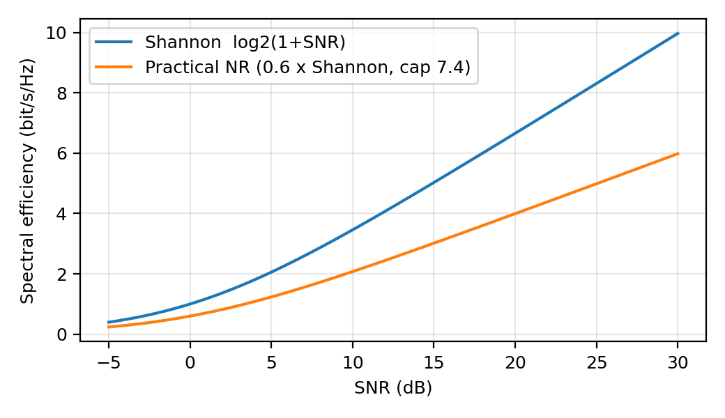
Figure 4. Shannon bound versus practical spectral efficiency
SNR (dB) | Shannon η (bit/s/Hz) | Practical η (bit/s/Hz) | Rate on 100 MHz, practical (Mbps)
0 | 1.00 | 0.60 | 60
5 | 2.06 | 1.23 | 123
10 | 3.46 | 2.08 | 208
15 | 5.03 | 3.02 | 302
20 | 6.66 | 3.99 | 399
25 | 8.31 | 4.99 | 499
Spectrum sizing example (urban 3-sector macro site). Design site load = 0.7 × 1.4 Gbps = 0.98 Gbps, i.e. 327 Mbps per sector. Effective efficiency = 6.0 bit/s/Hz × 0.74 (TDD DL share) × 0.8 (overhead) = 3.55 bit/s/Hz. Required bandwidth B = R/η = 327/3.55 ≈ 92 MHz, consistent with one 100 MHz n78 carrier. Doubling demand would need either 200 MHz, higher η (more MIMO layers) or more cells; this is the trade-off used in Design Decision 3.

4.4 Propagation loss, cell radius, interference and user distribution
- Propagation: from Figure 1, at 1 km the extra loss relative to 700 MHz is about 14.0 dB at 3.5 GHz and 31.4 dB at 26 GHz, so for equal path loss the radius falls by roughly 3× (3.5 GHz) and 15–20× (26 GHz).
- Cell radius vs capacity: area per site = 2.598R², so halving R quadruples sites per km²; capacity per km² rises about fourfold (with interference margin).
- Interference: SIR drops as cluster size shrinks (Table 9); cell-edge users (SINR 0–5 dB) obtain η of ~0.6–1.2 bit/s/Hz versus ~5 bit/s/Hz for cell-centre users (Figure 4).
- User distribution: non-uniform (hotspots near stations and venues) means average-based sizing underestimates peak cells; hence the 70% planning utilisation limit and the small-cell offload.

4.5 Latency and reliability budget
Table 14. One-way latency budget for vehicle URLLC (target ≤ 10 ms)
Component | Edge-hosted (ms) | Central cloud ~800 km (ms) | Notes
UE processing | 0.5 | 0.5 | Application and modem
Radio link (mini-slot, HARQ) | 1.0 | 1.0 | 30 kHz SCS, 0.5 ms scheduling, one retransmission allowance
RU–DU–CU / midhaul | 0.1 | 0.1 | Co-located DU/CU at far edge
Backhaul (fibre 5 µs/km) | 0.25 (50 km) | 4.0 (800 km) | Dominant difference
5G core user plane (UPF) | 0.5 | 0.5 | Local breakout at edge UPF
Application processing | 3.0 | 3.0 | Edge compute node
Total | 5.35 | 9.1 | Margin: 4.65 ms vs 0.9 ms
Interpretation. Radio and edge processing are fixed costs; backhaul distance is the swing factor. Central processing nearly consumes the 10 ms budget, leaving no room for retries or congestion, which justifies edge UPF/MEC for vehicle and industrial services. Industrial control (1–5 ms) additionally needs private 5G with on-site UPF.
Reliability. Target 99.999% (5 min/year). The series availability of radio, transport and edge/core is A = A_r · A_t · A_c. With each at 99.9995% (achieved through dual connectivity, diverse fibre/microwave and N+1 pools) A ≈ 99.9985%, so critical slices also use packet duplication and local survivability (edge continues services if core link fails). Radio BLER of 10⁻⁵ is obtained with robust MCS, repetition and diversity.

4.6 Mobility and handover continuity
Cell dwell time t = 2R/v for a vehicle crossing a cell diameter. Handover rate = 1/t.
Speed (km/h) | m/s | Dwell, macro R = 500 m (s) | Dwell, small cell R = 200 m (s) | Dwell, rural macro R = 1.66 km (s)
60 | 16.7 | 60.0 | 24.0 | 199.2
120 | 33.3 | 30.0 | 12.0 | 99.6
250 | 69.4 | 14.4 | 5.8 | 47.8
At 120 km/h a vehicle changes cell every 30 s on a 500 m macro layer but every 12 s on 200 m small cells. mmWave cells are therefore not used for continuous corridor coverage; corridors use n78/n28 macro with conditional handover and dual active protocol stack (DAPS, make-before-break) to keep interruption near 0 ms, with n258 only as an opportunistic capacity layer. Corridor sites are placed with overlapping coverage (about 20% overlap) and pre-configured neighbour lists, and the AMF/SMF/UPF anchor remains stable to keep sessions continuous.

4.7 Congestion, availability and performance thresholds
For a queue-like resource, mean waiting time scales as ρ/(1−ρ), so delay rises sharply as utilisation ρ approaches 1. Thresholds adopted:
Metric | Planning limit | Action trigger | Intervention
PRB utilisation (eMBB) | ≤ 70% | > 85% for 15 min | Load balance, add carrier, activate small cells
Call/session blocking | ≤ 2% | > 2% in busy hour | Add channels, split sector, offload
URLLC slice utilisation | ≤ 60% | > 75% | Pre-empt eMBB, increase guaranteed share
Backhaul utilisation | ≤ 70% | > 80% | Reroute, shape eMBB, activate microwave path
Service availability (eMBB) | ≥ 99.5% | < 99.5% | Capacity upgrade
Service availability (URLLC / public safety) | ≥ 99.999% | < 99.999% | Redundancy and recovery procedure

4.8 Assumptions and limitations
- Erlang B is for blocked-calls-cleared voice-like sessions; data traffic is bursty, so it applies to session and slice admission rather than eMBB throughput.
- Path loss uses simplified log-distance models; real planning needs 3GPP UMa/UMi/RMa models, terrain and clutter data.
- Demand per subscriber, vehicle counts and cost values are assumptions; sites per state are planning-level estimates.
- Cell capacities assume uniform loading and ignore inter-cell interference beyond the efficiency factor; real capacity varies ±30%.
- Idealised channel counts ignore guard bands, duplex overhead and control channels (stated in Section 1).
Design Decision 3 (main bottleneck and intervention per state). Using the capacity/coverage ratios in Table 10: Uttar Pradesh: capacity in urban, suburban and rural layers (ratios > 1) → improve spectral efficiency (massive MIMO) and add 100 MHz mid-band plus extra rural carriers, with prioritisation to protect URLLC. Tamil Nadu, Karnataka, Maharashtra, Gujarat: urban areas are coverage-limited in sites but peak hotspots and industrial/vehicle latency dominate → mmWave/pico offload and edge computing; rural layer capacity needs extra low/mid-band carriers. Kerala: dense continuous settlement and monsoon rain → additional micro cells on mid-band and resilient backhaul rather than mmWave. Supporting calculations: Tables 10 and 14 and the simulation in Section 8.

5. Stage 4: Architecture Evaluation and Selection

5.1 Alternatives
- Architecture A, macro-focused: sub-1 GHz and mid-band macro cells only, centralised core and cloud, no mmWave, limited edge (6 regional nodes).
- Architecture B, heterogeneous: macro cells (700 MHz + n78) plus small cells (n78 pico, n258 mmWave hotspots), 24 edge nodes (far-edge and near-edge), network slicing and AI-assisted RRM.
Table 15. Quantitative comparison (planning model, six states)
Metric | Architecture A | Architecture B
Macro sites | 117,231 | 115,253
Small cells (26 GHz / pico) | 0 | 12,310
Edge nodes | 6 | 24
5-year TCO (₹ crore, assumed unit costs) | 73,281 | 73,336
Hotspot peak capacity (26 GHz offload, 25% of urban demand) | Not available | Available
Vehicle URLLC latency (edge-hosted vs central) | ~9.1 ms (central), margin 0.9 ms | ~5.35 ms, margin 4.65 ms
Failure resilience | Single large cells, less overlap | Overlapping layers, dual connectivity, local survivability
Energy | Lower per site; higher per bit at peak | Higher site count; sleep modes give ~12% saving (simulated)
Deployment complexity | Lower | Higher (more sites, backhaul, orchestration)
Unit costs (assumed, blended new-build and upgrade): macro ₹0.30 crore CAPEX, small cell ₹6 lakh, edge node ₹2 crore; annual OPEX ₹6.5 lakh (macro), ₹0.8 lakh (small cell), ₹20 lakh (edge). To be replaced by vendor quotes.
The planning model shows the 5-year TCO of A and B to be almost the same (difference well under 1%) because urban sites are mainly coverage-limited, so mmWave small cells add cost but also relieve capacity and add edge capability. The decision therefore rests mostly on performance.

5.2 Weighted decision matrix
Table 16. Weighted decision matrix (scores 1 = poor, 5 = excellent)
Criterion | Weight (%) | Justification of weight | A score | B score | A weighted | B weighted
Coverage | 15 | Safety and universal service | 4 | 5 | 0.60 | 0.75
Capacity | 20 | Primary eMBB demand driver | 2 | 5 | 0.40 | 1.00
Latency | 15 | URLLC functionality | 2 | 5 | 0.30 | 0.75
Reliability | 15 | Critical and emergency services | 3 | 4 | 0.45 | 0.60
Scalability / 6G readiness | 10 | Future growth | 2 | 5 | 0.20 | 0.50
Deployment complexity | 5 | Operational risk | 4 | 2 | 0.20 | 0.10
Energy per bit | 5 | Sustainability | 2 | 4 | 0.10 | 0.20
5-yr cost (TCO) | 15 | Affordability (equal in model) | 3 | 3 | 0.45 | 0.45
Total | 100 |  |  |  | 2.70 | 4.35

5.3 Network slicing evaluation
Slice | Resource policy | Isolation | Edge / UPF | Scheduling
S1 eMBB | Shared, elastic, 40–70% of PRBs | Soft | Regional UPF | Proportional-fair, 256-QAM
S2 URLLC | Guaranteed 15–20% PRBs, reserved | Hard (dedicated RBs) | Far-edge UPF + MEC | Mini-slot, grant-free, 30 kHz SCS
S3 mMTC | 5–10% with power-saving | Soft | Central UPF | Grouped access, eDRX/PSM
S4 Public safety | Min. 8% reserved, pre-emptive | Hard + separate NSSAI | Local survivable UPF | Priority + pre-emption, MCPTT, 700 MHz anchored
Slicing provides isolation and tailored resource guarantees but needs orchestration and more complex monitoring. Hard-reserved slices waste capacity at low load; hence S2 and S4 reserves are kept small and lent back to eMBB through AI allocation (Section 8) with immediate pre-emption when needed.

5.4 Edge-computing locations and effect on latency
- Far-edge (corridor and factory sites, <20 km): V2X, industrial PLC; latency ~5 ms as in Table 14.
- Near-edge (district aggregation, ~50–100 km): remote healthcare, video analytics; ~6–7 ms.
- Regional core (state level, ~300–800 km): eMBB, mMTC aggregation, 9–12 ms. Each 100 km of fibre adds ~0.5 ms one-way.

surges5.5 Failures, backhaul congestion and demand
Failures are handled by overlapping layers (a failed macro is covered by neighbours and by 700 MHz), dual connectivity, diverse fibre and E-band microwave paths, N+1 pools of AMF/SMF/UPF, edge survivability and priority for S4. Backhaul congestion triggers shaping of S1 and rerouting; surge demand (events, disasters) triggers AI forecasting, small-cell activation and pre-emptive S4 protection. Architecture A has fewer degrees of freedom (no small-cell layer, central processing) and degrades more.
Design Decision 4 (selection). Architecture B is selected (weighted score 4.35 vs 2.70). Architecture A is rejected because it cannot offer hotspot capacity or vehicle latency margin (0.9 ms) and has weaker resilience. Sensitivity: if the dominant requirement became rural coverage (weights: coverage 40, capacity 5, cost 25), the scores are A = 3.08 and B = 4.29, so B remains ahead but the rural implementation reduces to the macro layer (mmWave and most small cells are deferred), i.e. B becomes close to A in deployment. If the dominant requirement became ultra-reliable vehicle communication (latency 30, reliability 30, cost 5), the scores are A = 2.63 and B = 4.50, and B’s lead widens, so edge density and dual connectivity along corridors would be increased first. If urban video throughput dominates, B with mmWave offload is again preferred.

6. Stage 5: Integrated 5G/6G Network Design
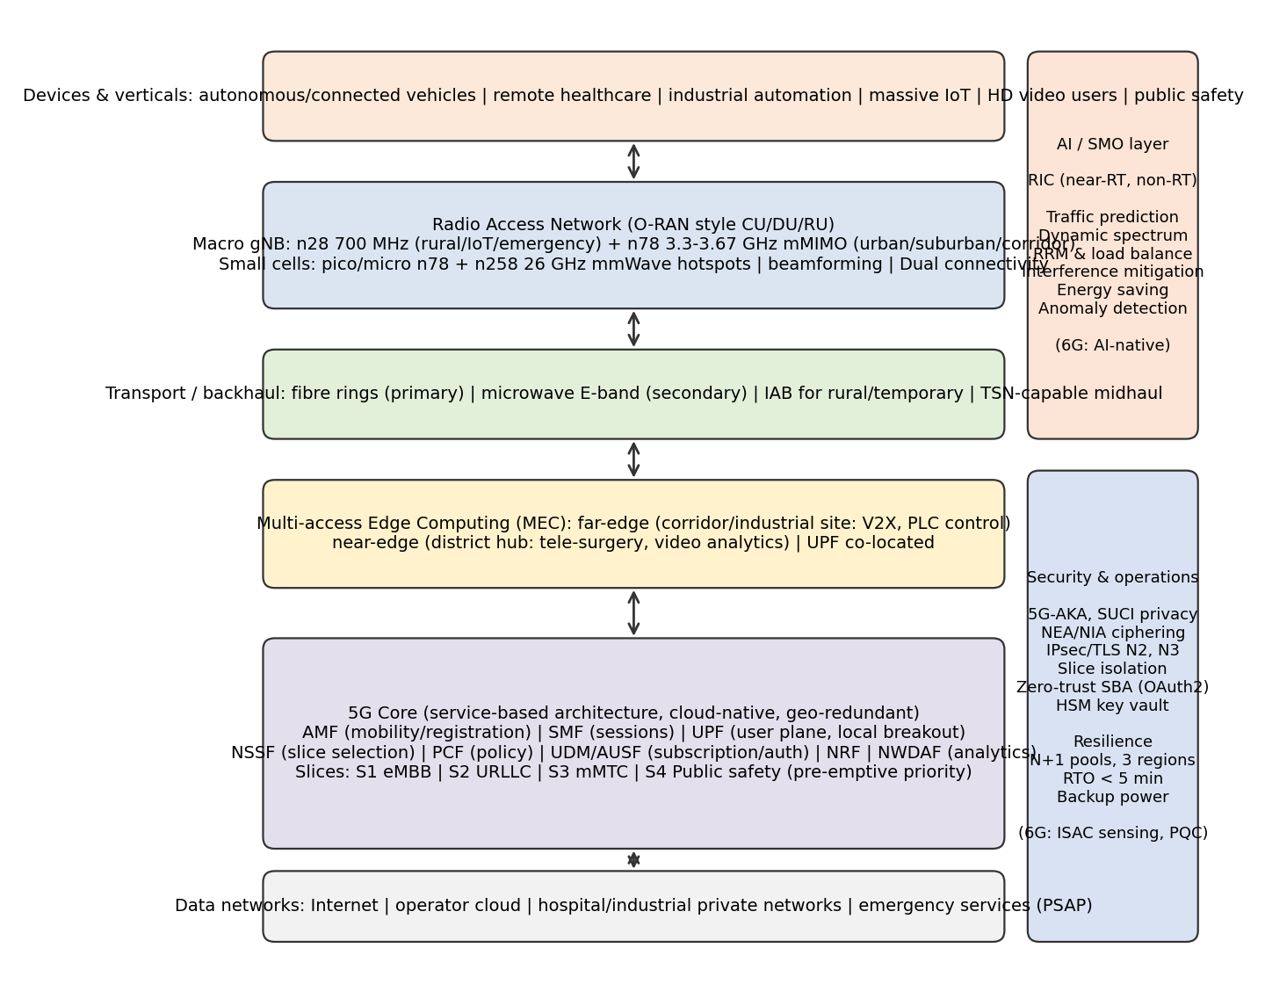
Figure 5. Integrated 5G/6G-ready architecture (layers, AI/SMO and security overlays)

6.1 State-wise radio-access architecture
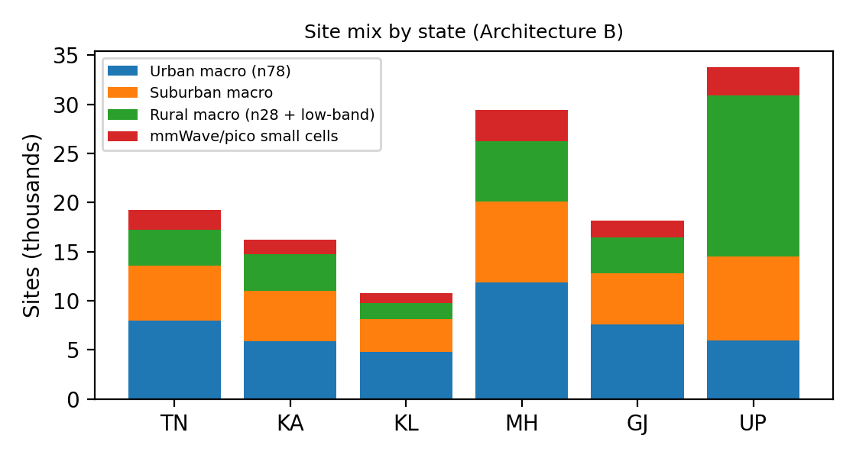
Figure 6. State-wise site mix of the selected design
Placement principles: (1) rural macro sites on existing towers/shared infrastructure at ~6 km spacing on 700 MHz, elevated in hills; (2) urban n78 massive-MIMO macro at ~0.5 km radius with tilt optimisation; (3) pico/mmWave at stations, malls, stadiums, campuses and hospitals where measured busy-hour demand is >70% of macro capacity; (4) corridor sites at ~1.5–2 km spacing with 20% overlap and edge nodes at toll plazas and interchanges; (5) every gNB has dual backhaul (fibre plus microwave) where possible. State-specific choices are in Section 3.7.

6.2 5G Core and traffic handling
- AMF (registration, mobility, NAS security): N+1 pools in three regional data centres.
- SMF (session management) selects the UPF by slice and location; UPF (user plane) at far-edge for S2/S4, regional for S1, central for S3.
- NSSF (slice selection), PCF (QoS/priority rules), UDM/AUSF (subscription and authentication), NRF (discovery), NWDAF (analytics feeding AI).
- Traffic flow: UE → gNB (N2/N3) → AMF (control) and UPF (user plane) → local breakout to MEC or data network (N6). Public-safety sessions are anchored to a locally survivable core that keeps working if the central link fails.

6.3 Logical network slices
Slice | S-NSSAI use | 5QI / QoS | Targets | Spectrum
S1 eMBB | Video, AR, broadband | Non-GBR / GBR video | ≥ 50 Mbps edge (urban) | n78, n258
S2 URLLC | V2X, industrial control, tele-surgery | Delay-critical GBR | ≤ 10 ms / 5 ms; 99.999% | n78 (30 kHz), n28 on corridors
S3 mMTC (massive IoT) | Meters, sensors, logistics | Non-GBR, low rate | 10⁶ dev/km²; 10-year battery | n28, NB-IoT/RedCap
S4 Public safety / emergency | MCPTT, first-responder data, alerts | Mission-critical, ARP pre-emption | 99.999% availability, coverage priority | n28 anchor + n78

6.4 Edge resources
Far-edge MEC (GPU-light, low-latency, 20–50 racks per state corridor cluster) hosts V2X road-hazard services, cooperative perception and PLC virtualisation; near-edge MEC hosts tele-health video analytics and AI inference; both host edge UPF. Placement is by delay budget (Table 14): far-edge when the budget < 6 ms, near-edge when 6–10 ms.

6.5 Mobility management
Xn-based handover within the same AMF, conditional handover and DAPS for corridors, RRC-inactive for IoT, neighbour-cell prediction from AI, session continuity modes (SSC mode 3 make-before-break for UPF relocation) and inter-state roaming with common AMF pools and consistent slice identifiers.

6.6 AI-enabled resource management
- Traffic prediction: time-series forecasting (LSTM/EWMA with trend) per cell and slice, 15-minute horizon, inputs from NWDAF.
- Radio-resource allocation (near-RT RIC): per-slice PRB shares set by the forecast plus a safety headroom (30% for URLLC); public safety always pre-empts.
- Congestion response: small-cell and carrier activation, load balancing, offload to mmWave; energy saving: sleep modes for small cells (<35% load) and carrier shutdown (<30%).
- Interference mitigation: learning-based beam and power coordination; anomaly detection on signalling and traffic for security.

6.7 Security and resilience
- Authentication with 5G-AKA/EAP-AKA’, SUCI concealment of subscriber identity, 128/256-bit NEA/NIA ciphering and integrity, IPsec/TLS for N2/N3, OAuth2-secured service-based interfaces, HSM-protected keys.
- Slice isolation, zero-trust segmentation between IT and OT networks, signalling firewall, DDoS protection, ML anomaly detection, secure supply chain, post-quantum readiness plan.
- Resilience: geo-redundant core in three regions, N+1 pools, diverse backhaul, 8–24 h battery or generator at critical sites, recovery target RTO < 5 min and RPO ~0 for subscriber data, regular failover drills.

6.8 Sustainability
- AI-driven sleep modes and carrier shutdown (~12% energy saving in the simulation), efficient massive-MIMO power amplifiers, infrastructure sharing (towers, power, fibre) among operators, solar-hybrid power for rural sites, reuse of existing sites, and EMF compliance with Indian limits (stricter than ICNIRP reference levels).

6.9 Emerging 6G concept
Integrated sensing and communication (ISAC) is proposed for transport corridors: the same mid-band/mmWave infrastructure senses vehicles, obstacles and animals, supporting AV safety and intrusion detection and reducing separate sensor deployments. AI-native networking extends Section 6.6 by embedding learning in the air interface and RIC. THz (100–300 GHz) links are long-term only for fixed hotspots and backhaul, because of very high path loss and short range (Figure 1 trend).

6.10 Validation method
Analytical models (Erlang B, link budgets, capacity), a 24-hour time-step slice simulation (Section 8), and the KPIs of Section 2.5. Recommended follow-up tools: ns-3 mmWave module, MATLAB 5G Toolbox, and drive-test calibration.
Design Decision 5 (how the components work together). Low-band macro cells give universal coverage and emergency/IoT service; mid-band massive MIMO gives urban and corridor capacity; mmWave small cells absorb hotspots; edge nodes and local UPF meet the latency budget; slices and AI share capacity while protecting critical services; security and redundancy protect availability. Implementable now (5G): n28/n78/n258 NR, massive MIMO, beamforming, slicing, SBA core, local breakout/MEC, dual connectivity, RedCap/NB-IoT, mission-critical services. Proposed future (6G): AI-native air interface, ISAC, sub-THz links, native sensing and large-scale distributed intelligence. The 5G design is made 6G-ready by using cloud-native core, open interfaces (O-RAN), spectrum and site capacity for upgrades, and edge compute that can host sensing and AI.

7. Stage 6: Validation

7.1 Validation of principal calculations
- Erlang B: recursion cross-checked by solving B(50,61) = 1.75% and B(50,60) > 2%, confirming that 61 is the minimum; B(50,55) = 5.37%.
- Cell counts: hexagon area 2.598R² (R = 0.5 km gives 0.65 km²); capacity sites rechecked with the Table 8 capacities.
- Spectrum: required 100 MHz per sector at 0.98 Gbps per site is consistent with Shannon limits at 15–20 dB SINR, where practical efficiency is 3–4 bit/s/Hz per layer and massive MIMO gives several layers.
- Latency: sums verified; backhaul 5 µs/km is the standard fibre propagation delay.

7.2 Architecture comparison against Stage 4 alternative
Architecture B provides hotspot capacity, a 4.65 ms (vs 0.9 ms) latency margin and better resilience at nearly the same modelled TCO as A, but with higher deployment complexity (more sites and 24 vs 6 edge nodes). It therefore remains the selected architecture.

7.3 Simulation method
A Python time-step model (5-minute steps over 24 h) represents one dense-urban cluster of 10 macro sites (14 Gbps) and 4 mmWave cells (0.96 Gbps each, 70% usable). Offered load has four slices: eMBB (diurnal, peak 8.5 Gbps), URLLC (up to 1.2 Gbps), mMTC (0.4 Gbps) and public safety (0.25 Gbps). Baseline: static slice split 72/14/6/8% with no offload. AI-assisted: forecast-based dynamic allocation (EWMA with trend, +5% safety), guaranteed minima for URLLC (30% headroom) and public safety (10% headroom), mmWave offload and pre-emption. URLLC delay is modelled as 1.0 ms + 0.25·ρ/(1−ρ) ms, energy as site power = idle + load-proportional, with sleep modes in the AI case. Random seed 7.

7.4 Scenario results
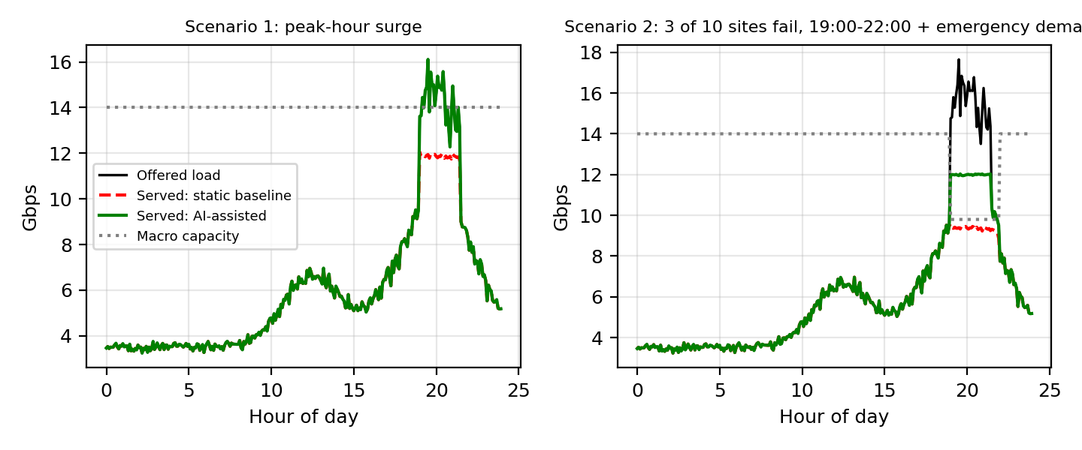
Figure 7. Offered and served traffic: Scenario 1 (peak surge) and Scenario 2 (failure + emergency)
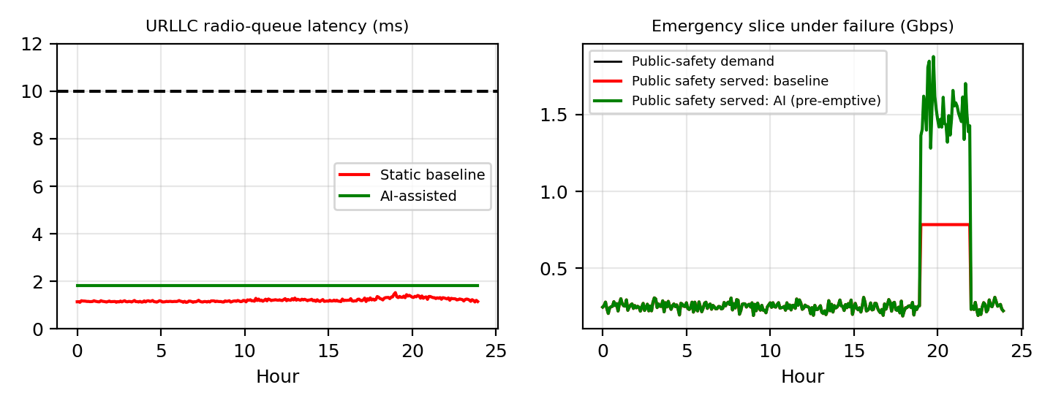
Figure 8. URLLC latency (left) and public-safety service during failure (right)
Table 17. Simulation summary
Metric | Normal day | Scenario 1: peak-hour surge (+55% eMBB, 19:00–21:30) | Scenario 2: 3/10 sites fail 19:00–22:00, emergency demand ×6
Unserved traffic, baseline (%) | 0.0 | 4.1 | 10.5
Unserved traffic, AI-assisted (%) | 0.0 | 0.0 | 5.9
Unserved eMBB, baseline / AI (%) | 0.0 / 0.0 | 5.5 / 0.0 | 12.4 / 8.1
Unserved public safety, baseline / AI (%) | 0.0 / 0.0 | 0.0 / 0.0 | 22.3 / 0.0
URLLC latency p99, baseline / AI (ms) | 1.42 / 1.83 | 1.42 / 1.83 | 2.98 / 1.83
Energy per day, baseline / AI (MWh) | 532 / 463 | 540 / 479 | 550 / 488
Energy saving (%) | 12.9 | 11.4 | 11.3
Interpretation. (1) In the peak surge the static split starves eMBB (unserved 5.5%) while URLLC reserves are idle; AI sharing and mmWave offload remove almost all loss. (2) In the failure plus emergency event, the baseline loses 22.3% of public-safety traffic, while the AI scheme with pre-emption serves all of it, at the cost of 8.1% unserved eMBB (graceful degradation; eMBB still falls because total capacity is lower). (3) In normal load the AI scheme gives slightly higher URLLC delay (1.83 ms vs 1.21 ms) because it provisions less idle headroom, still far below 10 ms; under failure its p99 is better (1.83 vs 2.98 ms). (4) Sleep modes save about 13% energy.

7.5 Limitations, risks and unresolved requirements
- The simulation is a simplified model (single cluster, ideal scheduling, no radio-channel fading or detailed mobility); results show relative, not absolute, performance.
- Several inputs are assumptions (subscriber counts, per-subscriber traffic, vehicle numbers, costs, spectrum availability and licensing).
- Risks: spectrum licensing and clearance (26 GHz equipment ecosystem), fibre and power availability in rural areas, monsoon and cyclone damage, right-of-way delays, EMF public perception, supply chain and cybersecurity.
- Unresolved: precise edge-site count and cost, exact backhaul topology, device ecosystem for n258/n28, and regulatory approvals for local/private networks.

7.6 Specification-verification table
Requirement | Design response | Evidence | Status
Blocking ≤ 2% | Provide 61 channels (A = 50 E) or sector/split | Erlang B: 1.75% at 61 | Met (needs +6 channels)
Coverage ≥ 99.5% population | n28 macro R~6 km rural; n78 urban; corridors | Link budgets (Table 7), site counts | Planned; needs field survey
Busy-hour utilisation ≤ 70% | Planning ρ_max = 0.7; AI load balancing | Table 10; simulation | Met in model
URLLC ≤ 10 ms | Edge UPF/MEC, 30 kHz SCS | 5.35 ms budget (Table 14) | Met (budget)
Reliability 99.999% | Dual connectivity, diverse backhaul, N+1 | Availability calculation | Design met; needs trials
Handover continuity | DAPS, conditional HO, 20% overlap | Dwell times (Section 4.6) | Met in analysis
Public-safety service in failure | Reserved slice + pre-emption | 0% unserved in Scenario 2 | Met in simulation
Energy saving ≥ 10% | AI sleep modes | 13% simulated | Met in model
Security | Authentication, encryption, isolation, anomaly detection | Design review | Met; needs penetration test
mMTC density 10⁶/km² | n28/NB-IoT + RedCap, grouped access | Spec. capability only | Needs measurement

8. Final Deployment Recommendation
Recommendation: deployment with modifications. Deploy Architecture B in phases: Phase 1, n28 coverage and n78 urban/corridor capacity with core, edge and slicing (S2 and S4 first); Phase 2, small cells and n258 hotspots after measured demand shows macro utilisation above 70%; Phase 3, AI-native features and ISAC pilots as 6G evolves.

Required modifications before rollout
- Replace assumed inputs by operator data (subscribers, busy-hour Erlang per user, available channels, vehicle counts) and re-run Erlang B and cell counts.
- Increase rural capacity (extra low/mid-band carriers) and confirm site sharing, because rural capacity ratios exceed 1 in all states.
- Validate with ns-3/MATLAB and drive tests, especially mmWave blockage, corridor handover and URLLC latency.

Key engineering assumptions and deployment risks
Assumptions: spectrum availability in n28/n78/n258; per-subscriber demand; log-distance propagation; unit costs. Risks: licensing, rural power and fibre, weather resilience, cybersecurity, and EMF concerns. Additional measurements needed: traffic per cell and hour, terrain-based propagation, interference scans, backhaul availability, and field tests of latency and handover.

Balance of coverage, capacity, reliability, spectral efficiency and cost
The design keeps coverage (n28, 6 km rural cells) and reliability (dual connectivity, redundancy, S4 pre-emption) as fixed requirements, puts capacity where measured demand is (n78 massive MIMO and small cells at ~6 bit/s/Hz), and controls cost by using mmWave only for hotspots and by sharing infrastructure; at the planning level its 5-year cost equals that of the macro-only design while giving higher capacity, lower latency and better resilience.

References
- 3GPP TS 38.104, NR; Base Station (BS) radio transmission and reception.
- 3GPP TS 38.211, NR; Physical channels and modulation (numerology, PRBs).
- 3GPP TS 23.501, System architecture for the 5G System (5GS).
- 3GPP TR 38.913, Study on scenarios and requirements for next generation access technologies.
- ITU-R Recommendation M.2083, IMT Vision: Framework and overall objectives of the future development of IMT for 2020 and beyond.
- ITU-R Recommendation M.2160, Framework and overall objectives of the future development of IMT for 2030 and beyond.
- T. S. Rappaport, Wireless Communications: Principles and Practice, 2nd ed., Prentice Hall, 2002 (Erlang B, reuse, SIR).
- A. Goldsmith, Wireless Communications, Cambridge University Press, 2005 (Shannon capacity, propagation).
- E. Dahlman, S. Parkvall, J. Skold, 5G NR: The Next Generation Wireless Access Technology, Academic Press, 2020.
- O-RAN Alliance, O-RAN architecture description (RIC and SMO).
- Department of Telecommunications / TRAI, India: spectrum band plan and EMF exposure guidelines (to be checked for current values).
- Python 3 with NumPy and Matplotlib for all calculations in this report.

